Tech Note 349
Adding Users to SuiteVoyager® Roles and Panel User Access
All Tech Notes and KBCD documents and software are provided "as is" without warranty of any kind. See the Terms of Use for more information.
Topic#: 001197
Created: March, 2004

Introduction
This Tech Note shows how to add users to SuiteVoyager 2.0 Security Roles and Panel User Access. Only domain users can be added using the SuiteVoyager Portal. Any user (domain or workgroup) can be added using Windows Component Services.
Typically SuiteVoyager will be run in a domain due to the centralized security maintenance that domains provide and the portal can be used to add users. However, for demo situations and small applications SuiteVoyager will sometimes be run in a Workgroup and then users will be added by using Windows Component Services.

Adding Domain Users to Security Roles and Panel User Access through the SuiteVoyager Portal
The SuiteVoyager 2.0 Portal only allows adding domain users to Security Roles and Panel User Access as can be seen below. More detailed documentation of this section can be found in the manual SuiteVoyager Portal Administration Help.
Figure 1 (below) shows the User Manager pane (found in Administration/User Manager), which indicates that only Domain Users can be added to Security Roles.
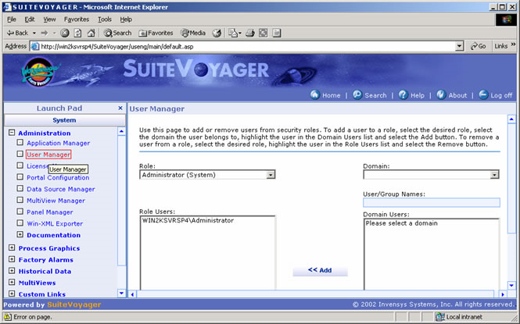
Figure 1: User Manager Pane
Figure 2 (below) shows the Panel User Access, which indicates that only Domain Users can be added to Panel User Access. This screen is found by going to Administration/Panel Manager, then selecting Edit for a Panel and then Users.
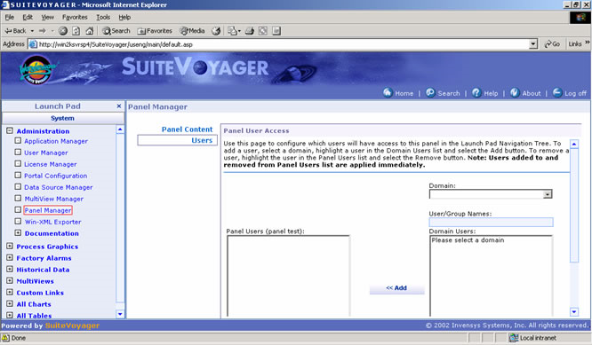
Figure 2: Panel User Access Pane

Adding Users to Security Roles and Panel User Access using Windows Component Services
The following steps are necessary to add non-domain users to Security Roles and Panel Access Users:

On the SuiteVoyager Node
- Open Control Panel/Administrative Tools/Component Services.
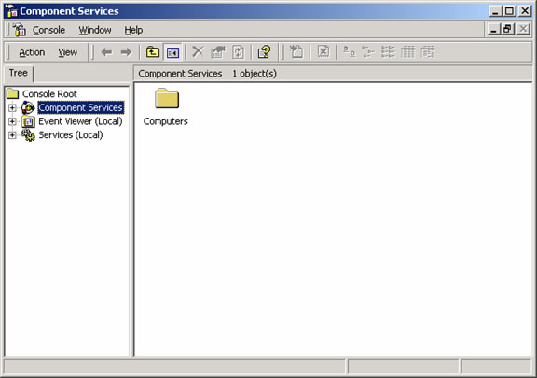
Figure 3: Component Services Window
- Drill down to Console Root/Component Services/Computers/My Computer/COM+ Applications/Wonderware SuiteVoyager/Roles (Figure 4 below):
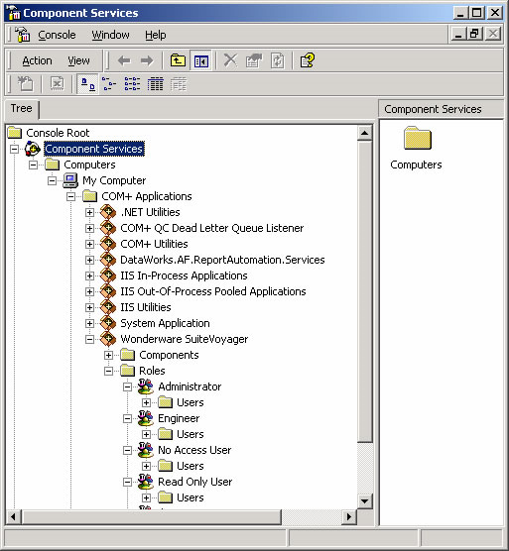
Figure 4: Roles
You can add users to the Administrator, Engineer, No Access User, and Read Only User Security Roles.
- Highlight the Users folder under any of the Security Roles.
- Select Action/New/User from the the menu. This new user can then be viewed through the SuiteVoyager Portal.
- Expand the Roles folder to view Panel Access Users.
Each panel has a folder with an ID string that ends with _PAL_ROLE (Figure 5 below):
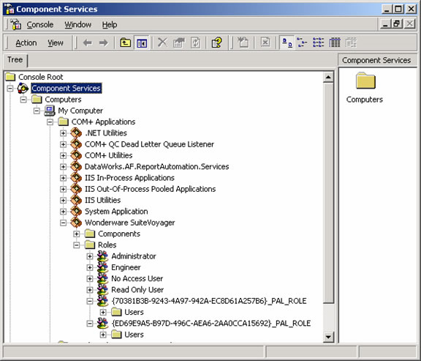
Figure 5: _PAL_ROLE Users
Here you can add users to the Panel Users Access:
- Highlight the Users folder under any of the Panels and then select Action/New/User from the main menu.
This new user can then be seen through the SuiteVoyager Portal.
D. Ujifusa
Tech Notes are published occasionally by Wonderware Technical Support. Publisher: Invensys Systems, Inc., 26561 Rancho Parkway South, Lake Forest, CA 92630. There is also technical information on our software products at Wonderware Technical Support
For technical support questions, send an e-mail to support@wonderware.com.
back to top
©2011 Invensys Systems, Inc. All rights reserved. No part of the material protected by this copyright may be reproduced or utilized in any form or by any means, electronic or mechanical, including photocopying, recording, broadcasting, or by anyinformation storage and retrieval system, without permission in writing from Invensys Systems, Inc. Terms of Use.

