Tech Note 132
Using FactorySuite 2000s WWClient to Check I/O Server Communications
All Tech Notes and KBCD documents and software are provided "as is" without warranty of any kind. See the Terms of Use for more information.
Topic#: 000767
Created: November 6, 1998

Introduction
WWClient is a generic DDE- and Suitelink™-aware utility that is automatically installed with the Wonderware® FactorySuite™ 2000. This utility allows you to quickly and easily test a Wonderware I/O Server configuration. (WWClient also provides scripting capabilities to automate the process.) This Tech Note shows how to use WWClient to test an I/O Server’s communications to a PLC, directly or across a network. This Tech Note also shows how to troubleshoot an I/O Server by temporarily eliminating communications from specific client applications, such as InTouch™.
Note This Tech Note addresses only the basic features of WWClient. For more information on configuring the Wonderware I/O Server with the PLC, consult the Wonderware User Guide for the particular I/O Server that is available online on the FactorySuite CD-ROM.
For InTouch 6.0 and earlier, see Tech Note 48 “Using WWClient to Check DDE Server Communications.”

Location of the WWClient Utility
After you install the desired components of FactorySuite 2000, the WWClient utility is located under the Start Menu, under Wonderware FactorySuite, then Common. When you start up WWClient, the Wonderware Client window will appear:
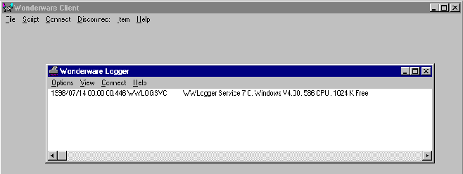
(Note that the Wonderware Logger will also automatically start. Minimize the WWLogger window for now so that you can clearly see the Wonderware Client window.)

Procedure

Testing the DDE Conversation to the I/O Server
Note We will use the example of using WWClient to test the Wonderware Allen-Bradley Ethernet Direct I/O Server, which is attached to an Allen-Bradley Ethernet-capable PLC or SLC processor. The Application, Topic and Item names used in this example will vary with your configuration, depending on the I/O Server and PLC that is used.
- Start up the I/O Server and view the configuration to make sure that it’s configured correctly. Then, minimize the window. (See the Wonderware User Guide for your particular I/O Server for more information on configuring I/O Server.)
- Start up WWClient. When the WWLogger window appears, minimize the window so that you can see WWClient’s Wonderware Client window.
- Select Connect from the WWClient menu. The Connect dialog box will appear:
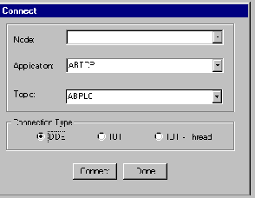
- Type in the name of the I/O Server in the Application listbox (example, “ABTCP” for the ABTCP I/O Server) and the Topic name in the Topic listbox (example, “ABPLC”).
Select either the DDE or IOT radio button. (If your Wonderware I/O Server is release 7.0 or greater, then it can communicate using SuiteLink. You can verify the I/O Server release by selecting Help/About from the I/O Server menu.)
Then click the Connect button. You should see an established DDE conversation to the I/O Server appear in the Wonderware Client window as shown in the example below.
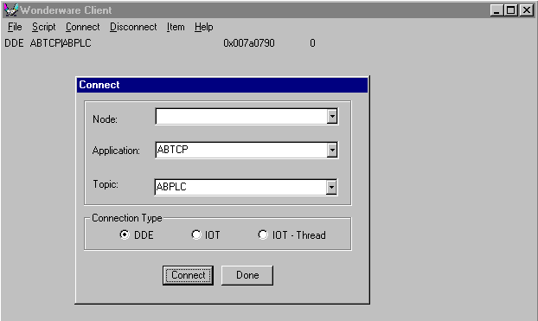
Note If the I/O Server is on a remote computer, you must include its node name in the Node listbox. If you are running Microsoft® Windows™ 95, make sure Wonderware’s NetDDE is installed and configured on the computer. If you are running Windows NT, make sure Microsoft’s Network DDE and/or Wonderware’s SuiteLink is installed; make sure both Windows NT services are in Automatic mode and have a Status of Started; and make sure the DDE Shares have been configured. (For more information on configuring NetDDE and the DDE Shares, see the NetDDE section of the Wonderware Knowledge Base.)
If the DDE conversation does not appear, then the connection to the I/O Server failed. (This is the same as InTouch issuing the error “Could not Initiate DDE Conversation.”) Check the following:
- Verify that the I/O Server is properly configured and running.
- Verify that the I/O Server’s name is spelled correctly in the Application listbox on the Connect dialog box.
- Verify that the Topic name was created in the I/O Server. Also, verify that the Topic name is spelled correctly in the Topic listbox on the Connect dialog box.
- Verify that the I/O Server can support the selected Connection Type on the Connect dialog box. (Remember that only version 7.0 and later of a Wonderware I/O Server can use the IOT connection type.)
- Click the Done button once you have verified the DDE conversation was successful to the I/O Server.

Testing the I/O Server With the Register and Advise Commands
- Select Item from the WWClient menu. The Item dialog box will appear:
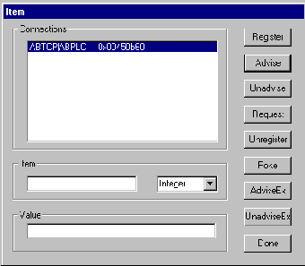
- Type in a valid Item name that you want to read a value from in the Item listbox. (Example, “S:23”, which is the real time in seconds for an Allen-Bradley PLC 5 processor or “S:4” which is the real time in seconds for an Allen-Bradley SLC processor.)
Select the type of the Item from the dropdown list (that is, Integer, Real, Discrete, or String).
- Click both the Register and Advise button respectively or the AdviseEx button.
You should see the Item appear and then its value to the right in the Wonderware Client window, as shown in the example below. The example below shows that the Item is being updated every second. This confirms that the I/O Server is configured properly.
You will see an error stating that the Advise operation failed if it was unable to display the Item and its value. You should also check the WWLogger window for any related error messages. If you receive an error from WWClient, check the I/O Server configuration, the PLC hardware and its software settings, cabling, and other related items.
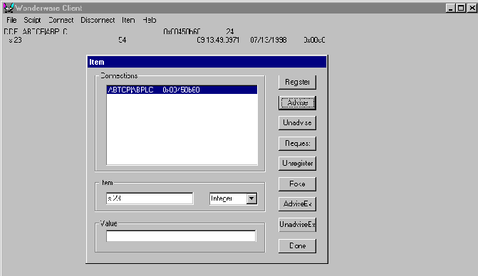

Testing the I/O Server With the Poke Command
Do these steps to see if WWClient can successfully Poke (that is, write) a value to an Item in the PLC.
- Select Item from the WWClient menu. The Item dialog box will appear:
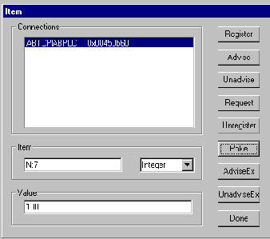
- Type in the Item name for a valid and configured PLC in the Item listbox to which values can be written. Then select the Item name’s type from the dropdown list (that is, Integer, Discrete, Real, or String). In our example, we entered the Allen-Bradley File N7 as the Item name and Integer as the type.
Type in a valid number for the Item name in the Value listbox (example, 100).
Click the Poke button. You should see the value of 100 written and displayed in the Allen-Bradley N7 File as shown above.
- Confirm that the Poke command was successful by executing the PLC’s programming software and viewing the data table(s) in the PLC.
Or, create another Topic name in the I/O Server and repeat steps 1 and 2 to reference the same Item name through the newly created Topic name, then, “poke” a value to the new Topic name.
For example, here are the results of two Topics that were connected, ABPLC and ABPLC2:
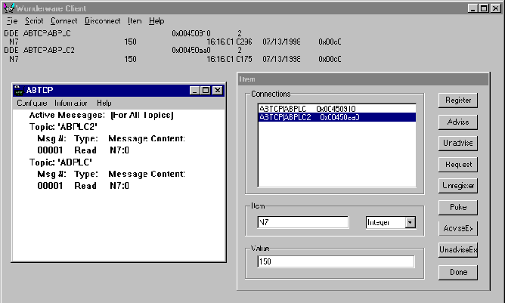
The ABPLC Topic is advising the Item N7. As shown above, there is a Poke command on this same Item by the ABPLC2 Topic. By using this method, you can confirm that the Poke command was successful without the use of the PLC programming software.

Removing DDE Conversations by Item and Topic
To remove the DDE conversation by Item name, do these steps:
- Select Item from the WWClient menu and highlight the desired Topic name from the Connections list as shown in this example:
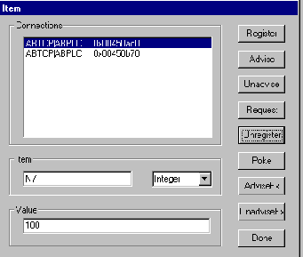
- Type in the Item name in the Item listbox from which you wish to remove the DDE conversation.
Click either the Unregister or UnadviseEX button. The Item name will be removed and no longer appear in the Wonderware Client window.
To remove the DDE conversation by Topic name, do these steps:
- Select Disconnect from the WWClient menu. The Disconnect dialog box will appear.
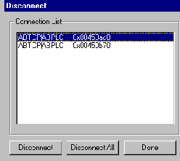
- Highlight the desired Topic name from the Connection List from which you wish to remove the DDE conversation, as shown in the example above.
Click the Disconnect button. The Topic name will be removed and no longer appear in the Disconnect dialog box and in the WWClient screen.
B. Maglinao
The Tech Note is published occasionally by Wonderware Technical Support. Editors: Sabrina Abercromby and Kelly Hauser; Publisher: Wonderware Corporation, 100 Technology Drive, Irvine CA 92618. There is also technical information on our software products at Wonderware Technical Support, our WonderFax fax-on-demand system at (949) 450-5050, and the Comprehensive Support Knowledge Base.
For technical support questions, send an e-mail to support@wonderware.com.
back to top
© 2011 Wonderware Corporation. All rights reserved. Terms of Use.

