Tech Note 214
Finding Memory Leaks in Windows 2000
All Tech Notes and KBCD documents and software are provided "as is" without warranty of any kind. See the Terms of Use for more information.
Topic#: 000933
Created: April 26, 2001
This Tech Note shows you how to use Windows 2000 Task Manager and Performance Monitor to collect system information, in order to assist Wonderware® Technical Support in identifying memory leaks.
Note: This Tech Note utilizes Windows 2000 built-in utilities. If you are using Windows 95 or Windows 98, you will need a third-party, after-market software (i.e., Norton Utilities) to obtain diagnostic capability. Also see Tech Note Number 213.

Background
There are times when Wonderware Technical Support will ask you to set up diagnostic software to help identify possible memory leaks with programs running on your system.
Memory leaks are caused by programs that use up system resources (i.e., memory, hard drive space, etc.) without releasing the resources back into the system, causing a lack of resources available for Windows to function. Memory leaks are normally suspected when a known working Windows system crashes or completely locks up over a certain period of time, and for no apparent reason.

Using Windows 2000 Task Manager
Windows 2000 Task Manager can be used to isolate memory leaks and system failures that occur in a short period of time, such as a day. To set up Windows 2000 Task Manager, perform the following steps:
Note: This Tech Note assumes that all software needed to recreate the memory leak is running on the system.
- Press the <Ctrl>+<Alt>+<Del> keys. A Windows 2000 Security dialog box will appear.
- Click on the Task Manager button. The Task Manager dialog box will appear (Figure 1).
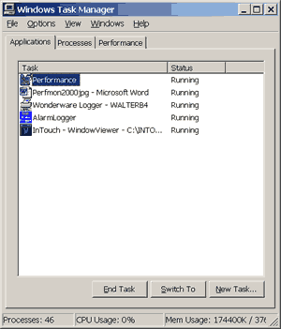
Figure 1: The Windows Task Manager Dialog Box
- Click on the Processes tab.
- From the menu bar, select View/Select columns.
- Check all boxes as shown in Figure 2.
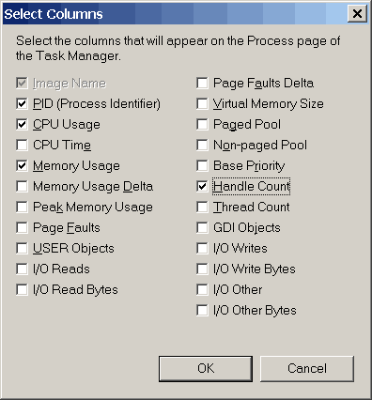
Figure 2. Setting Up the Select Columns Dialog Box
- Let the system run for about 10 minutes, then record the column values for each program (i.e., View, I/OServer, any custom program, etc.) that may be running on your system.
This information can be viewed from the Processes and Performance dialogs shown in Figures 3 and 4.
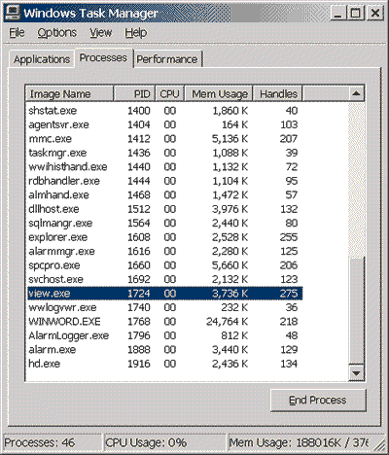
Figure 3: The Windows Task Manager - Viewing Processes
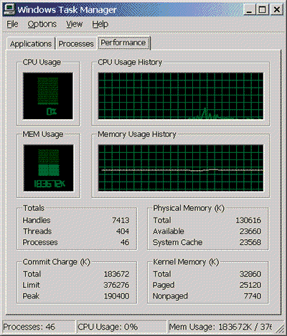
Figure 4: The Windows Task Manager - Viewing Performance
- Continue to record the column values every couple of hours.
  - These samples will be used to find a trend in resource consumption.
  - Memory leaks are detected over time, when certain values continue to climb without stabilizing or going down.

Using Windows 2000 Performance Monitor
Windows 2000 Performance Monitor is used when the column values collected from the Task Manager are insufficient in determining where the problem is, or the memory leaks occur over a longer period of time, such as a week or longer.
One Performance Monitor file, .blg, will be required to record and analyze the data. The .blg file is the Performance Monitor Binary log file of the recorded information.

Creating the .BLG File
- Open the Performance Monitor from Start/Programs/Administrative Tools/Performance. The Performance Monitor window will appear (Figure 5).
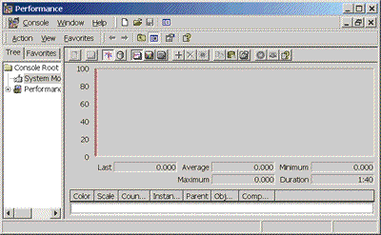
Figure 5: The Performance Monitor Window
- Expand the menu tree for Performance Logs and Alerts shown in Figure 6.
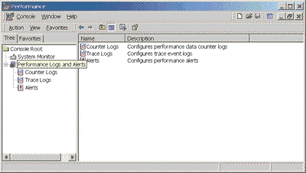
Figure 6: The Performance Window - Performance Logs and Alerts
- Right-click on Counter Logs and select "New Log Settings."
- Enter the log file name, then press OK (Figure 7).
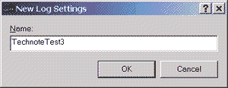
Figure 7: The New Log Settings Dialog Box
- You should see a dialog window with 3 tabs, General/Log Files/Schedule (Figure 8).
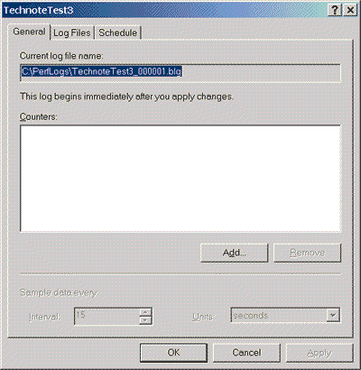
Figure 8: The TechnoteTest3 Window - General, Log Files, and Schedule Tabs
- Click the Add button.
- Check "Use local computer counters" or "Select counters from computer," as shown in Figure 9.
- Under the "Performance object" pull-down menu, select "Memory."
- Check the radio button for "Select counters from list."
- Select "Available Mbytes," then click the Add button.
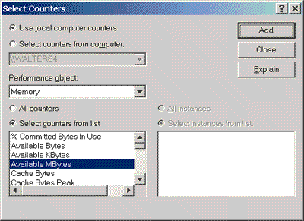
Figure 9: The Select Counters Dialog Box - Use Local Computer Counters
- Select "Committed bytes" and click Add.
- Under the "Performance object" pull-down menu, select "Process" (Figure 10).
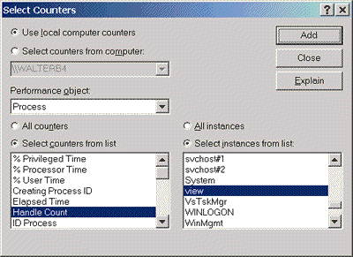
Figure 10: The Select Counters Dialog Box - Process
- Check the radio button for "Select instances from list."
- Select "Handle Count," then choose an instance of a Program to monitor.
- Click Add.
- For the same program, also select "Private Bytes," "Thread Count," and "Virtual Bytes." "Click Add after each."
- Repeat steps 9-16 for all the programs you wish to monitor.
- Press the Close button (Figure 10) to verify all the counters in the list (Figure 11).
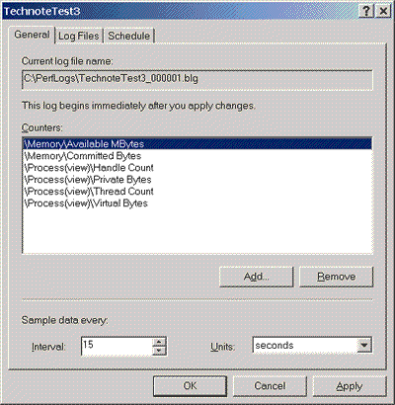
Figure 11: The TechnoteTest3 Window - Log Settings
- Select the Log Files tab as shown in Figure 12.
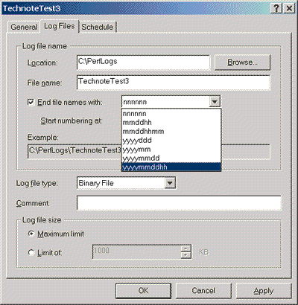
Figure 12: The TechnoteTest3 Window - Log Files Tab
- Verify the location and file name.
- Check "End file names with."
- From the pull-down menu, select "yyyymmddhh."
Note: From this pull-down menu you can take a Binary log file and convert it to a .csv file format, or use it for additional troubleshooting. This is done under the "Log file type" menu.

Scheduling the Logging
The Scheduling tab in Performance Monitor provides the added functionality of choosing when to start and stop Logging. This is useful for scenarios where crashes occur repeatedly at specific times.
Note: If the issue occurs randomly, it is recommended that you manually start and stop the logging.
The following steps describe how to manually start and stop the logging:
- Select the Schedule tab (Figure 13).
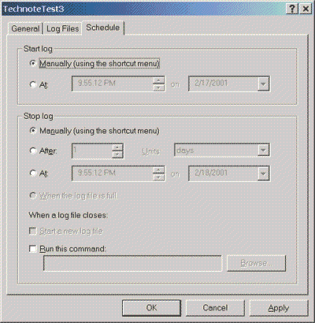
Figure 13: The TechnoteTest3 Window - Schedule Tab
- Select "Manually" under the "Start log" section.
- Press the Apply button, then click OK.
- Select "Counter Logs" from the left menu-tree item (Figure 14).
- Select and right-click on the log file to start and stop Logging.
Note: Log files will light up Green when logging is active and will display Red when inactive.
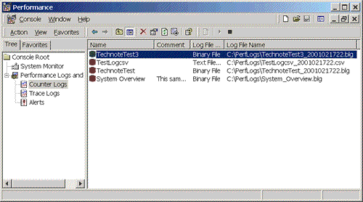
Figure 14: The Performance Monitor Window - Counter Logs
- When logging is complete, send the .blg file to Wonderware Technical Support for evaluation.
Note: To view live information from the Counters logged from the log file, perform the following steps: a) Right-click on the chart, then select Properties/Source tab; b) Check the Current Activity radio button to view present information; c) Press Apply.

Saving Live Counter Chart Settings in a Separate .msc File
Counters selected for the main chart can also be saved in a separate .msc file, which can be loaded at any time. This feature allows you to quickly load counter chart information previously saved.
The following procedure describes how this file can be created:
- Select the Counters you wish to view (Memory, Process, etc.) as seen in the "Creating the .blg File" section of this document.
- Click the Console button on the top of the screen.
- Select "Save As," and provide a file name, such as TechnoteTest.msc. This file can now be loaded at any time, to view live information with the Counters presently selected.

Wonderware Technical Support Accessing the Problem
Once the files are received, Wonderware Technical Support will view the log and chart information as follows:
- Click on the System Monitor icon (Figure 5).
- On the main Performance Monitor screen, right-click on the Chart graph and select "Properties."
- Choose the Source tab, then select the Log File radio button.
- Click the Browse button (Figure 15).
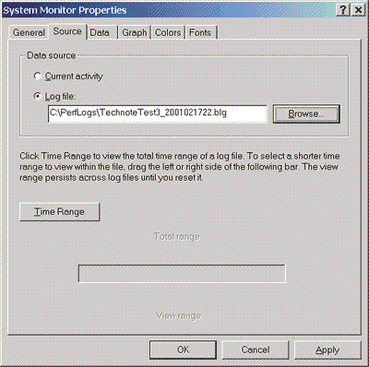
Figure 15: The Source Tab - Browse Button
- Select the current log file and click Open (Figure 16).
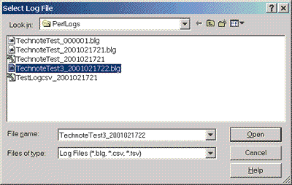
Figure 16: Selecting Current Log File
- Press Apply, then press OK.
- Right-click on the graph, then select "Add Counters." You should see all counters that have been recorded.
- Select a performance object, click all instances of counters that have been logged, and press Add (Figure 17).
- Click the Close button.
- Review the recorded information.
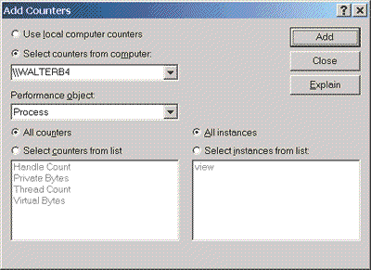
Figure 17: The Add Counters Dialog Box - Log Settings
Note: To view live information from counters logged from the log file, perform the following steps: a) Right-click on the chart, select Properties/Source tab; b) Check the Current Activity radio button to view present information; c) Press Apply.
Wonderware's Technical Support can now view the log information via the original chart settings that were used to record the information.

Summary of the Counter Types Used in this Document
The following figures are the counter types used in this Tech Note.
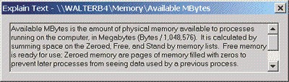
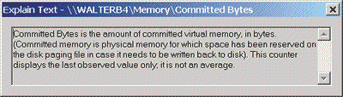
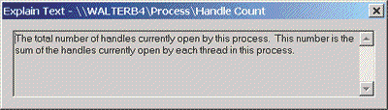
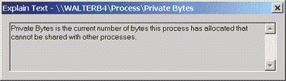
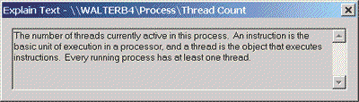
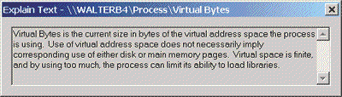
D. Boyd
The Tech Note is published occasionally by Wonderware Technical Support. Publisher: Wonderware Corporation, 100 Technology Drive, Irvine CA 92618. There is also technical information on our software products at www.wonderware.com/support/mmi, our WonderFax fax-on-demand system at (949) 450-5050, and the Comprehensive Support Knowledge Base.
For technical support questions, send an e-mail to support@wonderware.com.
back to top
© 2003 Wonderware Corporation. All rights reserved. Terms of Use.

