Tech Note 230
Troubleshooting the Browser-based Window's Live-data Issues
All Tech Notes and KBCD documents and software are provided "as is" without warranty of any kind. See the Terms of Use for more information.
Topic#: 000958
Created: June 4, 2001

Summary
This Tech Note describes the mechanisms involved in moving live data from an InTouch™ application, running and acquiring plant-floor data, to a SuiteVoyager™ browser-based window. In addition, troubleshooting techniques for determining why there is no data being displayed in the window are covered.
There are several areas that can be checked in the event that no data is present in a browser-based window. The first indicator to check is the live-data-update indicator bar. This bar resides in the lower left-hand portion of the browser window and appears to move back and forth. The update indicator bar should appear within approximately 15 seconds of opening a browser-based window containing live data. The data-source location must be correct. This can be verified by checking the windowset properties in the Win-XML exporter.
All browser-based window data is delivered by the Wonderware® RDB Handler Service. Communication between InTouch Windowviewer, or the data source, and the RDB Handler is done via SuiteLink™. This communication link, just as the link between InTouch and an I/O Server, can be tested using the WWClient. There is a small variation in the setup of WWClient for checking communication through the RDB Handler versus through an I/O Server. That difference will be covered in this document. It is also imperative that the execute permissions be correctly set for the SuiteVoyager installation within Internet Information Services.

Providing Data for Factory Clients
Below is an excerpt from the SuiteVoyager Administrator's Guide. It discusses the engine that supplies data from the factory floor to the portal.
SuiteVoyager is a data portal that aggregates information from plant-floor data sources. It does not replicate information. It takes users of the thin clients directly to the source of the data. But, no matter how many people are connected to the portal, the additional network load will be that of only one InTouch node. Therefore the plant-floor network engineer can rest assured that this product will not cause him to upgrade his bandwidth to handle the 300 concurrent users the portal can support.
Between the Internet/Intranet clients and the portal, the protocol is HTTP. From the portal to the plant-floor data sources such as View, InControl, or I/O Servers, the protocol is SuiteLink. SuiteVoyager uses ADO and OLE DB from the Active Server Pages to access information from databases such as InSQL™, AlarmSuite™, or InTouch™ 7.1 Alarm Logger. Data sources for the portal must be located in and accessible via the same LAN (Local Area Network) as the portal. All clients must have access through the Internet or the Intranet.
The SuiteVoyager Portal uses a set of data handlers that speak HTTP on one side and the plant-floor protocols on the other. These handlers run as services within the IVFW framework, an ISAPI application that interacts directly with the Internet Information Server and re-directs messages to the appropriate data handlers. In addition, its task is to establish and maintain a session between the client and the handler. The data handler itself manages and maintains connections to the data sources.

Viewing Live Data Over the Internet
To view live data over the internet, the Web server must be accessible over the internet. There are times when data updates as expected when viewed from within the Web server's domain or locally, but does not update when viewed from an internet client. It is important that the published windowsets, requiring accessibility over the internet, be published to the correct Web server URL. The use of the WWClient utility for troubleshooting data update issues is covered in the following sections.
When configuring SuiteVoyager to provide this capability it is advised that your IS or IT department, or personnel that handles those responsibilities, be involved.

Checking the Data-source and RDB-handler Status
The data source for a windowset will normally be the InTouch View application, but it can also be an I/O Server or another application that is running somewhere on the domain. The location of the data source is included in the converted window XML code as well as the windowset configuration file. It can also be verified through the WinXMLExporter.
This Tech Note covers the WinXMLExporter method of checking the data source. It is important that the data source be verified. Is it in the location where it should be?
- Open up the WinXMLExporter (Figure 1).
  - From here the data source location can be checked.
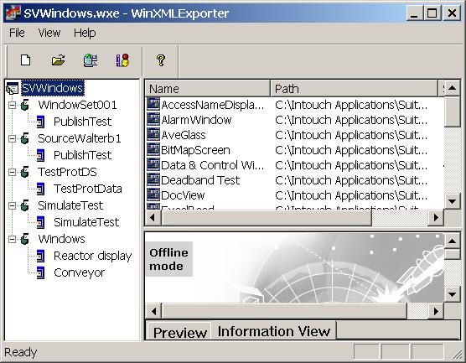
Figure 1: The SVWindows.wxe - WinXML Exporter
- You can see the properties for WindowSet001 in Figure 2.
  - This window shows that SuiteVoyager is installed on computer walterb4.
  - The Data Node Name, the node that InTouch View resides on, is also walterb4.
  - Note the similaritiy to configuring a tagname server access name in InTouch.
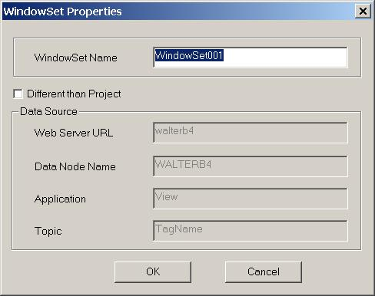
Figure 2: The WindowSet Properties Dialog Box - The WindowSet001 Properties
- Figure 3 shows the properties for the WindowSet Source Walterb1.
  - This is an example of an installation where the data node is different from the SuiteVoyager node.
- You can change the WindowSet properties as follows:
  - First, check the Different than Project box.
  - Then make the changes and select the OK button.
  - Once the OK button is selected and the window is closed the Different than Project box is deselected.
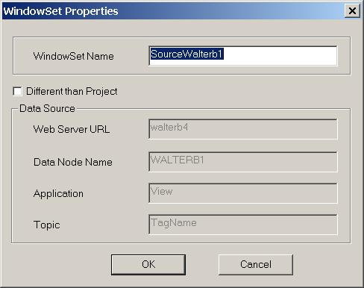
Figure 3: The WindowSet Properties Dialog Box - The WindowSet SourceWalterb1 Properties
- To verify that the Runtime DB Handler service is running, open the Services window and find the item.
  - In a Windows 2000 Server environment, it will look like Figure 4.
  - Note that the Status is Started.
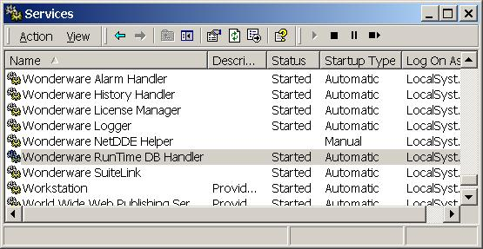
Figure 4: The Services Window
- If the service is not started, start it and try to reestablish a connection.
Once the data source is confirmed as correct and the RDB Handler is running, the next troubleshooting step can be performed.

WWClient and the RDB Handler
The WWClient utility is a tool that has been used in the past to check communication from a data source, such as a PLC, through an I/O Server to InTouch. Tech Note 48 is a good reference for using WWClient for this purpose. With a slight variation, it can be used to check data-flow through the RDB Handler. Just as WWClient is installed as part of InTouch, it is also installed with SuiteVoyager. If data is not being delivered by the RDB Handler, data will not update on the browser-based window.
- Run the WWClient utility from the Web server machine.
  - Normally WWClient can be run from the Start menu.
- Select Start/Programs/Wonderware Factory Suite/Common.
  - The installation location and interface are shown in Figures 5 and 6, respectively.
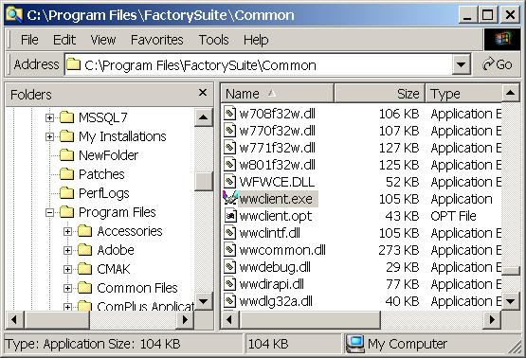
Figure 5: The WWClient Installation Location
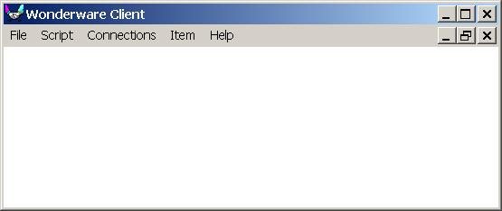
Figure 6: The Wonderware Client Window
As previously stated, WWClient is used to check communication from the data source, located either locally, remotely within a LAN, or over the Internet, through the RDB Handler. A connection needs to be established from WWClient to the data source. The data source can be Intouch View, an I/O Server, or a different data provider. This is done very similarly to the procedure from Tech Note 48. The difference is, in this case Intouch View will normally be addressed instead of an I/O address.
- Figure 7 shows the Create Connection window.
  - Notice the Node entry.
  - In this case the walterb4 is the node name of the SuiteVoyager, or the Web-server computer. An IP address or internet URL can also be used here.
  - The @ is the signifier that informs WWClient to look to the RDB Handler for data.
  - The walterb1 entry is the data source node name.
  - In this example, View is the data source and is located on node walterb1.
  - Also notice that IOT (Suitelink) is selected.
  - Suitelink is the communication protocol between SuiteVoyager and the RDB Handler.
- If the data source is not View, enter the appropriate Application and Topic.
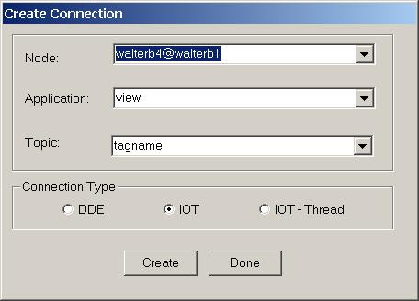
Figure 7: The Create Connection Dialog Box
- If a successful connection is established, there will be an entry similar to the one displayed in Figure 8.
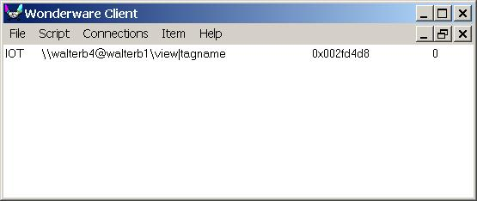
Figure 8: The Wonderware Client Window Showing a Successful Connection
- If a connection does not appear, or appears quickly and then goes away, a successful connection has not been made. There are a few different issues that can cause this to happen.
  - The Wonderware Runtime DB Handler service is not running.
    - The Runtime DB Handler should have been checked and started, if necessary, as explained in the previous section of this Tech Note.
  - The portal execute permissions for the Web-site scripts are not set properly.
    - If the Runtime DB Handler service is indeed started, the reason for the connection failure could be the execute permissions for the Web-site scripts.
  - The connection configuration is incorrect.
    - Make sure that the Node, Application, and Topic fields, as well as the Connnection Type are correct.
  - A network problem exists between the Web server and the data source.

Checking the Connection Failure
- Open the Computer Management window.
  - Right-click on My Computer and select Manage; or
  - Open from Start/Programs/Administrative Tools/Computer Management.
  - The Computer Management window will appear (Figure 9).
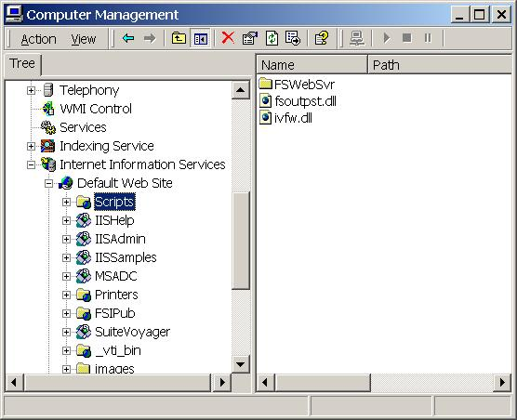
Figure 9: The Computer Management Window
- Find the Scripts folder and right-click the mouse on it.
- Select Properties.
  - The Scripts Properties box will appear (Figure 10).
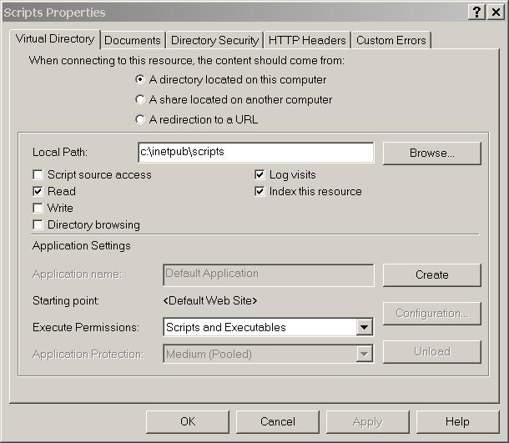
Figure 10: The Scripts Properties Dialog Box
- Does the Execute Permissions entry agree with the configuration shown?
- If Scripts and Executables is not shown in the Execute Permissions box, please select it from the drop-down menu.
  - The RDB Handler executable file as well as other executables are contained in the FSWebSvr folder, which can be seen is a sub-folder of Scripts.
  - For this reason the permissions shown are required.
- Try to reestablish a connection again.
  - Hopefully a connection could be established after these efforts.
  - If a connection still could not be made, there may be a network-related issue.
- Contact Wonderware Technical Support for further assistance.

Determining if Data is Streaming through the RDB Handler
The next step is to check an item to determine whether data is streaming through the RDB Handler.
- If the data source is View, $Second is a good item to advise.
- If a different data source is used, select an item that is changing regularly.
- Once the item name is entered, select AdviseEx (Figure 11).
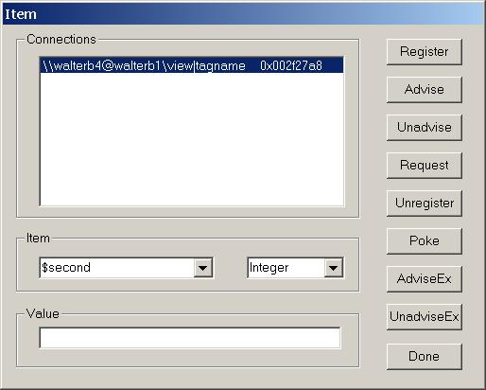
Figure 11: The Item Dialog Box - Checking the Data Source
- After selecting AdviseEx, the item value should be displayed as seen in Figure 12.
  - It should agree with the actual value in the data source.
  - If the item does not advise, the item value will not appear in the window.
  - An item may not be advising because the Suitelink service on the data-source node is not running.
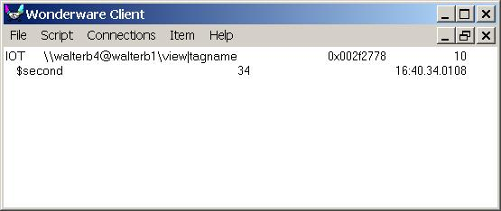
Figure 12: The Wonderware Client Window Displaying the Item Value
- If the item did not advise, verify that the Suitelink service is started.
- To verify that the Wonderware Suitelink service is running, open the Services window and check the Status.
  - In a Windows 2000 Server environment, it will look like it does in Figure 13.
  - Note that the Status is Started.
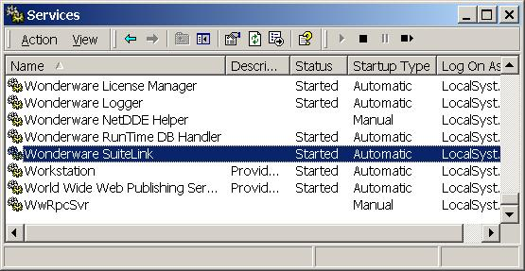
Figure 13: The Services Window Confirming that SuiteLink is Started
- If the service is not started, please start it and try to advise the item again.
- If the Wonderware Suitelink service is running and a item cannot be advised, contact Wonderware Technical Support for further assistance.
W. Boncal
The Tech Note is published occasionally by Wonderware Technical Support. Publisher: Invensys Systems, Inc., 26561 Rancho Parkway South, Lake Forest, CA 92630. There is also technical information on our software products at www.wonderware.com/support/mmi
back to top
© 2003 Invensys Systems, Inc. All rights reserved. No part of the material protected by this copyright may be reproduced or utilized in any form or by any means, electronic or mechanical, including photocopying, recording, broadcasting, or by any information storage and retrieval system, without permission in writing from Invensys Systems, Inc.

