Tech Note 280
InTouch 7.11 Alarm Hot Backup and Alarm Acknowledgement Synchronization
Topic#: 001068
Created: October, 2002
This Tech Note describes the basic usage of Hot Backup and Alarm Acknowledgement synchronization in InTouch 7.11. Also covered are examples of implementation and architecture. This system is covered fairly well in the InTouch User Guide. There are segments of information contained there that need further explanation for use in an actual application. The information located in the InTouch User Guide are important notes and Frequently Asked questions that relate to the configurations described later in this Tech Note.
Note--This Tech Note covers some general uses of the Alarm Hot Backup Synchronization. Your application may require different settings. This Tech Note is meant to cover the majority of the installations that would be able to use the Alarm Hot Backup Synchronization. Throughout this Tech Note, the terms Primary and Secondary, and Hot and Backup are used interchangeably.

Alarm Hot Backup Synchronization
The Hot Backup system provides a fail-safe system for critical conditions. If the Primary provider stops responding, Hot Backup automatically switches to the Backup provider and returns to the Primary provider automatically when the primary is live.
Note--The DAO object has to be opened with the query pointing to MyPair on the consumer node in order to synchronize between Primary and Backup.
- Alarm Hot Backup Synchronization can only be utilized on systems containing 3 or more PC's.
- InTouch is the only Provider supported for Hot Backup pairs.
- Alarm Synchronization is only provided for Condition based alarms only and is not supported for expanded summary alarms or event-oriented alarms.
- Alarm Hot Backup Synchronization will require some application management, because an alarm Provider (Primary or Backup) cannot Query or have configured a Hot Backup Pair that contains its own node name. Please refer to InTouch User Guide Notes for more information regarding Hot Backup pairs.
The Alarm Hot Backup system is Client-based. The entire configuration for the Hot Backup Pair is held in the Client application. A Client cannot have a pair configured that contains its own node name, nor can any other pair contain the names of nodes that are already used in a pair. The nodes called out in the Primary Node and Backup Node fields must also be two separate PC's.
In the example below a three nodes system is displayed. Node A, Node B, and Node C. Nodes A & B are the Alarm Providers, and Node C is the Client (consumer).
Node-C (Client / Consumer)

Node-A (Primary) Node-B (Back up/Secondary)
Figure 1.1
Alarm Providers:
- Node A - No Hot Backup Pair configured.
- Node B - No Hot Backup Pair configured.
- Keeps track of alarmable items.
- Provides alarms to alarm Consumers.
Alarm Consumer:
- Node C - Hot Backup Pair called 'MyPair'. Node A is the Primary, and Node B is the Backup.
- Receives alarms from any node on the network.
- Acknowledges alarms across the network.
- Uses alarm query that references Hot Backup pair.
Provides synchronization between Primary and Backup.
Note-- The DAO object has to be open with query pointing to MyPair name on the consumer node in order to synchronize between Primary and Backup).
There are some assumptions in this architecture:
- That Node A and Node B both have the same Tagname Dictionary. That they both have the same data source either to the same IOServer, or two different IOServer's that point to the same PLC's if this is true, then when an alarm occurs on Node A, it is also occurring on Node B.
- The purpose of having a backup Alarm Provider is to establish a failsafe system – to ensure that alarms will be generated for certain critical circumstances by having a secondary Alarm Provider take over issuing alarm notifications if the primary Alarm Provider fails.
- Alternatively, the primary Alarm Provider may be a "full-blown" application, while the secondary Provider is a "minimal" system, handling only the most critical parts to keep the equipment functioning and undamaged. Generally, only certain key Alarm Providers will be backed-up with secondary Alarm Providers. You will need to map your Alarm Providers whenever the primary and secondary Alarm Providers are not identical applications. To map alarm records please refer to the InTouch User Guide.
- That all of the PC's are on the same network, and can communicate with each other.

Hot Backup Configuration
The Hot/backup pair is defined only on the clients. No configuration is required in Providers, the hot and backup machines have no clue that they have those roles, nor do they communicate directly to synchronize alarms. When a pair is created, you have to indicate what alarm group is to be mapped between the hot and the backup providers. Typically you would like to configure your pair to get all alarms, so you would normally configure the pair to use the $System group.
• Create a new InTouch application on the client node.
• Start InTouch WindowMaker.
• Double-click the Alarm Hot Backup Manager item in the Application Explorer.
The Alarm Hot Backup Manager dialog box opens:
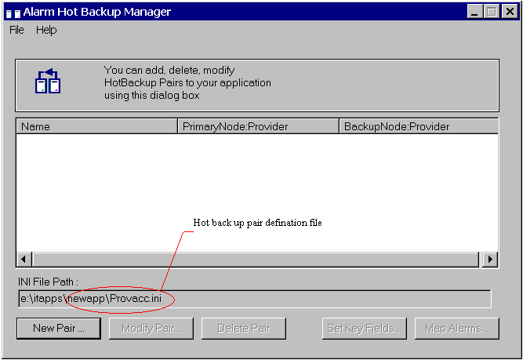
Figure 1.2
Note-- By default, the utility automatically checks for the Provacc.ini file in the last opened InTouch application folder. If the file is available, the utility will configure itself with the file. Otherwise, the utility will create a new file in the required folder. Using file menu option you can modify the Provacc.ini file configuration. (It is recommended that the Provacc.ini file is located in the application directory.)
1. Click the New Pair button.
The Add New Pair dialog box opens:
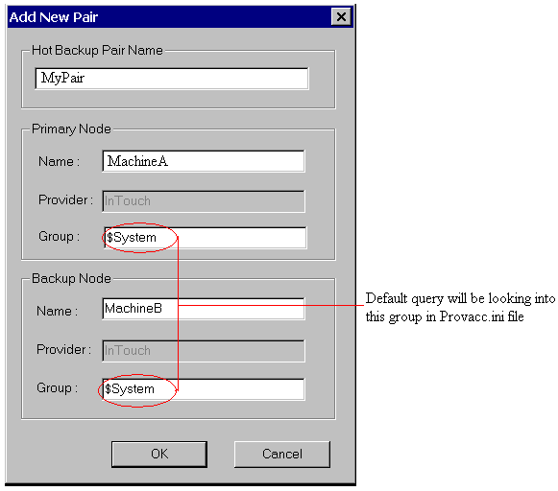
Figure 1.3
4. In the Hot Backup Pair Name field, type a unique name for the new pair. Pair names can be up to 32 alphanumeric characters long. (Note: Duplicate pair names are not allowed. Underscore is the only special character that is allowed at the beginning, middle or at the end of the Hot Backup pair name.)
5. In the Name field in the Primary Node group, type the name of the computer where the primary provider application is running. Node names can be up 32 alphanumeric Characters long. (Note: The node name for a particular application must be unique for the entire Hot Backup listing. An appropriate error message box appears if you enter wrong or duplicate entries.)
6. In the Provider field in the Primary Node group, type the name of the provider of the Alarms. For example, InTouch. Provider names can be up 32 alphanumeric characters long.
7. In the Group field in the Primary Node group, type the name of the Alarm Group for Querying alarms from the primary provider.
Configure the Backup Node and must follow rules 5 to 7.
8. Click OK. (Note: You must execute the Save command on the File menu to save all your changes to the INI files. You will be prompted to save changes before exiting the utility.)

Alarm Hot Backup Synchronization
The back up pair configuration should have completed design time and runtime mapping of the certain key fields. The default mapping is Alarm Name. This checkbox is always checked by default, however the user can change it if required. The most important thing to know about Alarm Hot Backup Synchronization is that IT ONLY TAKES EFFECT WHEN A DAO IS LOADED IN MEMORY AND IT USES THE PAIR NAME AS ITS UNDERLYING QUERY on the client node. That means that the alarm sync between hot and backup alarm providers is lost when the window hosting the DAO is closed or when its query is modified via AlmQuery() function. At that time, any alarms Acknowledged on the Hot machine are not Acknowledged on the Backup machine because the client is not using the pair. The acknowledge synchronization will take place only when window that contains the DAO on the client is re-opens. What this means is users must have a DAO on the client app that uses the pair if they want to see alarms synchronized between hot and backup machines.

References
- FAQ 31
- Intouch User Guide
G. Subramani
Tech Notes are published occasionally by Wonderware Technical Support. Publisher: Invensys Systems, Inc., 26561 Rancho Parkway South, Lake Forest, CA 92630. There is also technical information on our software products at www.wonderware.com/support/mmi
For technical support questions, send an e-mail to support@wonderware.com.
back to top
©2004 Invensys Systems, Inc. All rights reserved. No part of the material protected by this copyright may be reproduced or utilized in any form or by any means, electronic or mechanical, including photocopying, recording, broadcasting, or by anyinformation storage and retrieval system, without permission in writing from Invensys Systems, Inc. Terms of Use.

