Tech Note 307
MultiMonitor Support for FactorySuite 2000® and FactorySuiteA²™
All Tech Notes and KBCD documents and software are provided "as is" without warranty of any kind. See the Terms of Use for more information.
Topic#: 1115
Created: March, 2003
This Tech Note explains the use of MultiMonitors within the InTouch® visualization environment. It is intended to provide a brief overview of MultiMonitor Technology and tips on choosing the proper card to use with your Wonderware® Software. This document also includes some common troubleshooting MultiMonitor issues from the InTouch standpoint as well as Frequently asked questions regarding MultiMonitors.
Note Since so many multi monitor cards are available, this document lists only MultiMonitor cards that are known to be compatible with InTouch.

MultiMonitor Technology Overview: Hardware/Drivers
A MultiMonitor system is a computer with more than one monitor connected to it, either by adding additional video cards or by using video cards with multiple outputs (ports).
Each monitor becomes a part of the desktop, enabling the mouse to move freely between monitors. You can drag windows from monitor to monitor, or stretch them across multiple monitors.
Prior to Windows® 98, a MultiMonitor system could only be created with the use of a special video card that had multiple monitor outputs and software to run it. The Microsoft® Windows 98 operating system was the first OS to introduce built-in MultiMonitor support. This allows a computer to take 2 or more standard video cards and run windows on all monitors.

Video Hardware
Video hardware configuration can be divided into two categories:
A. One Individual Video card using custom drivers with multiple outputs (Ports).
or
B. Multiple Standard Video cards using Windows MultiMonitor support.
Another component we must also look at are the Video drivers used in the above hardware configurations.

Video Drivers
Video driver configuration can also be divided into two catetories:
A. Drivers capable of configuring 1 virtual desktop across multiple monitors.
or
B. Drivers that control individual multiple desktops.

Video Driver Characteristics
Category A drivers include the following characteristics:
- Capable of configuring 1 virtual desktop.
- Monitor settings and configuration are available for 1 monitor.
- The Windows taskbar extends across multiple monitors (when configured in a side-by-side layout).
- Windows applications can be maximized to fit all monitors.
- These types of drivers are typically made for custom video cards with multiple ports.
Category B drivers include the following characteristics:
- Capable of configuring multiple desktops.
- Monitor settings and configuration are available for each monitor.
- The Windows taskbar is fixed/assigned to one primary desktop (monitor).
- Windows applications can only be maximized on one primary designated monitor.
- This type of driver is provided by Windows support or as a standard driver for custom video cards.

Category A Driver Properties
Here's how the display properties look in a 4-monitor system with a Category A driver (following figure). Display settings are available for 1 monitor; i.e. you only have to configure 1 resolution, color depth, and refresh rate. The resolution setting is the resolution for the full display area of all monitors combined. In this figure the resolution setting is for 4 monitors configured in a side by side layout with a resolution of 1024 x 768 per each monitor. This gives us a total viewing area of 4096x768:
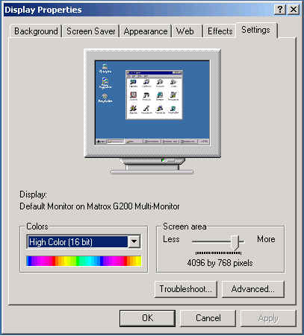
Figure 1: Single setting across multiple monitors
Note This same configuration in a Windows NT® environment is for the resolution of 1 monitor only since NT will propagate this resolution automatically to all available monitors.

Category B Driver Properties
Here's how Display Properties look in a 4-monitor system with a Category B driver (following figure). Resolution, color depth and refresh rate are configurable for each monitor. By dragging the monitors, you can adjust their position to match the physical arrangement of the actual monitors on your desktop:
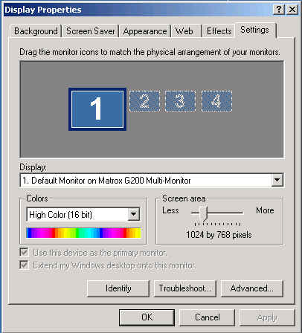
Figure 2: Multiple monitor settings

InTouch and MultiMonitors

Now that we are familiar with MultiMonitor basics, what environment is suitable for InTouch?
InTouch requires a Category A driver configuration (1 virtual monitor environment) to be completely functional and fully supported. This support includes InTouch 7.1, 7.11, and 8.0.
Within the Category A environment, InTouch.ini and Win.ini settings must be set to complete the IDEAL MultiMonitor configuration. The ini settings enable InTouch to properly place system dialogs and keypads in the proper locations on the monitors. These ini settings were first implemented in InTouch 5.x and have been functional for all subsequent versions. These ini settings are as follows:

Settings: InTouch.ini
- ScaleForResolution=0
When set to 0, scaling and/or resolution conversion is disabled.
When set to 1, scaling and/or resolution conversion is enabled.
Note If this entry has not been added to the ini file, the default value is Enabled (ScaleForResolution=1).
This setting is used to keep the application resolution intact (for windows graphics) when migrating between machines with different resolutions as you would see in a MultiMonitor environment.
Note When this configuration is disabled (ScaleForResolution=0) you will be prompted to convert the resolution. However, the conversion will not occur.

Settings: Win.ini
- MultiScreen=1
- MultiScreenWidth=1024
- MultiScreenHeight=768
The MultiScreen setting can be set to 0 or 1 to disable or enable MultiMonitor functionality.
The MultiScreenWidth and MultiScreenHeight indicate the screen resolution for 1 monitor in the system.
For further examples and information on these settings please see tech article 000202 Using Multiple Monitors in InTouch.
Also see the troubleshooting section of this document for the MultiMonitor test application.

Will InTouch work in a Multidesktop Category B driver environment?
The answer is Yes, with conditions:
When using InTouch with a Category B driver, you will see the following issues:
- WindowViewer™ cannot be maximized across all monitors, it will only maximize on the primary monitor. This will create issues if InTouch security is used and the application is maximized to secure the windows desktop. WindowViewer however can be run in a minimized mode without security and can be manually stretched across all of the monitors.
- The above-listed ini settings do not work in this environment.
- System dialogs may show split between monitors or forced to only the primary monitor.
- Not recommended as ideal for InTouch.

Choosing MultiMonitor Cards
The following cards have been tested and are recommended by Wonderware:
- ColorGraphics Predator LT 2 and 4 *
- ColorGraphics Multiscreen LT4 PCI *
- Matrox G200 Quad *
- ATI Radeon 8500 Dual
- Appian RushMoore 4 Monitor
Note * indicates video cards that have Category A drivers capable of configuring 1 virtual monitor. These are ideal for InTouch and recommended. The other cards listed have only Category B drivers available at the time this document was written.
The above cards have been tested on Windows 2000 and Windows XP operating systems with InTouch 7.11 and 8.0.
Please see the following links for Technotes describing the Ideal configuration, details and drivers for each card listed:
- ColorGraphics Predator LT 2 and 4
- ColorGraphics Multiscreen LT4 PCI
- Matrox G200 Quad
- ATI Radeon 8500 Dual
- Appian RushMoore 4 Monitor

Tips for Building MultiMonitor Intouch Applications
Building a MultiMonitor application is really no different from building a normal single monitor application except you now have a larger viewable area to work with. When building a MultiMonitor application there are a few guidelines and items that will ensure easier deployment:

Determine the Overall Screen Resolution
Determining your overall screen resolution and knowing the exact size of your viewing area will make things much easier when developing windows. Draw out the over all monitor configuration on a piece of paper documenting the max resolution for each monitor and the whole combined resolution. This will act as a roadmap to help visualize the amount of pixels available when determining window sizes and shapes.

Determine if You are Going to Build the Application on a Single Monitor or Multiple Monitors
It is always easier to develop an InTouch application within the environment in which it will be running. This may not be an option in some cases. In the scenario where only one monitor exists on the development node, you can still build a MultiMonitor application by developing the windows and configuring the windows dimensions and locations to your projected display needs (following figure):
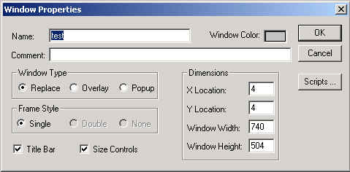
Figure 3: InTouch Window property settings for MultiMonitor display
These settings are configured by right-clicking on a window in WindowMaker and selecting Properties from the submenu.
The X and Y Location: values determine where the window will be placed in runtime (View). The settings are referenced from the upper-left corner of the window.
The Window Width- and Height: settings determine the overall size of the window.
As an example you can have a window configured with the following settings:
- X location = 1025
- Y location = 0
- Window Width = 1024
- Window Height = 768
In this example we have 4 monitors set in a side by side layout. The overall resolution is 4096 X 768. Each monitor has a resolution of 1024 X 768.
By setting the X location to 1025 and the Y location to 0, we have forced this window to show on the second monitor during runtime and cover the whole screen.

Determine the Overall Application Window Placement
Several different configurations can be used when developing InTouch windows for this environment. One method is to simply develop and force windows to show where specified, as seen in the previous figure. This involves making sure that WindowViewer is maximized across the total viewing area of all monitors. This enables:
• The InTouch Application Windows to be shown on specified monitors, and;
• Utilization of InTouch security to lock out the windows desktop.
Another option is to develop an application where windows are manually moved to the monitors of choice, allowing a single application to run on different monitor configurations. This involves the following:
- All windows in the application must be of type Popup.
- The Main WindowViewer Parent window can be small and not covering all monitors. However, InTouch security (for locking out the desktop) cannot be used in this configuration because InTouch is not Maximized.
In this configuration Popup windows are used which can be easily moved to any monitors, regardless of the Main WindowViewer Parent window location. Popup windows do not have to remain within the Parent WindowViewer Window. The main window can be simply shrunk down in size and moved to a corner of a monitor, allowing all the popup windows to be moved freely to the monitors of choice.
The final method includes an additional step added to the above method. The step allows an application to automatically place windows based on the environment used. This is the most complicated of configurations and requires extensive scripting and planning.
In this configuration, the ShowAt and ShowAtTopLeft script functions are used to dynamically place windows based on a default set of coordinates and calculations. This can be configured many different ways depending on your application requirements.

Make Sure InTouch Patches are Up to Date
Before you develop your application, it is very important to make sure that your development environment(InTouch) is at the latest proper patch level. Throughout the history of FactorySuite there have been many functional changes that can greatly affect how your application will operate. Make sure to document the exact version of Intouch that was used when the application is was developed. This can be found under the Help/About menu command in WindowMaker or WindowViewer™.
By doing this, it will make it easier to identify any problems or functionality changes which may occur if the application is run on a system with a different patch level version.

Deploy the Application and Check the ini Settings
The ScaleForResolution ini setting becomes particularly important when an application is developed on a single monitor system but is intended to run on a MultiMonitor system. As described above in the ini section of the document, this setting will prevent the application from being scaled when moved from one environment to the other.
For example, if an application was developed on a single monitor machine with a resolution of 1024 x 768 and was intended to run on a system with 4 monitors in a side by side configuration with a total resolution of 4096 X 768, this would require an application conversion.
When the application is deployed on the (destination) MultiMonitor system, the following message window will appear (following figure):
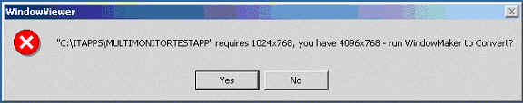
Figure 4: Resolution change prompt
If the ScaleForResolution ini setting is configured, you will still see this message but the application will not be converted and can then be run as designed. Simply click Yes to continue startup.
If the ini setting is not configured, InTouch will convert and scale all of the graphics and windows in the application to the new resolution. Doing so will stretch and enlarge all windows and graphic displays, thus creating some unwanted results.
For this reason it is also recommended that a backup copy of the application is kept at all times in order to recover from unwanted changes such as these.
Note Make sure that the MultiMonitor Win.ini settings are also configured on the destination machine prior to running your application. Win.ini settings do not automatically transfer with an InTouch application.

Troubleshooting FAQs
Problems encountered in a MultiMonitor system when used with InTouch can be somewhat confusing.
The following section discusses a few items to help make Troubleshooting an easy task.
MultiMonitor issues are most commonly directly related to Video drivers and Configuration settings for both InTouch and the video driver. When trying to identify problems or isolate an unwanted behavior in your MultiMonitor System, the following guidelines are recommended:
- Identify your Video driver version number. This number can be found on the Adapter tab when viewing the Windows Display properties.
- Go to the card manufacturer's website and locate the latest drivers available for your Operating System. Compare the latest version to your existing driver. There may be an updated driver available which repairs certain issues or provides additional functionality for your Video Card.
- Determine if the driver used is a Category A or B driver as listed in this document. Verify that the issue you are seeing falls under the known functionality for the Category driver used.
- Identify whether the Display Properties show settings for 1 Virtual monitor or Multiple individual monitors.
- Determine whether the Windows taskbar extends across Multiple monitors or 1 monitor (Applies to monitors configured in a side by side layout).
- Verify that the InTouch .ini settings have been configured properly (applies only to Category A drivers.)
- If using a card listed in this document, read the associated technote to ensure proper configuration.
- Use the MultiMonitor Test Application and steps listed below to help isolate the issue.
- Contact Technical Support with the above information and steps to reproduce the issue.

Manufacturer Links for the Cards Listed:
- www.colorgraphic.co.uk/index.html
- www.matrox.com
- www.ati.com
- www.appian.com

Frequently Asked Questions
- What MultiMonitor cards are supported for use with InTouch?
Presently, the ColorGraphics LT 2 & 4, ColorGraphics MultiScreen LT4 PCI, and the Matrox G200 Quad video cards have been tested by Wonderware Technical support and are considered to be fully compatible with InTouch.
- Can I use built-in Windows MultiMonitor support?
Yes, this environment is considered a Multidesktop Driver B environment that will work with Intouch but with known problems. Please see the Intouch and MultiMonitor section of this document.
- Why did my application change after transferring it to my MultiMonitor machine? -- The ScaleForResolution .ini setting was not configured in the Intouch.ini file. This must be configured to prevent Intouch from scaling the application transferred to a MultiMonitor machine. Please see the Intouch and MultiMonitors section of this document for more details.
- Why do my system dialogs and keypads show stretched or split between my Monitors?
This can occur if you are in a MultiDeskTop Category B driver Environment or if you do not have the MultiMonitor ini settings configured in the win.ini file. Please see the InTouch and MultiMonitors section of this document for more information.
- Why does the ShowAt() and ShowAtTopLeft() function only show windows on one Monitor?
This can occur if you are in a MultiDeskTop Category B driver Environment. InTouch must be configured in a 1 virtual Monitor environment using a Category A driver for the ShowAt() and ShowAtTopLeft function to work properly. Please see the first section of this document for further details.
- My MultiMonitor application Windows no longer show/display properly after upgrading InTouch or installing Patches?
This applies to applications using the ShowAtTopLeft() function to place windows. This issue occurs when an application has been developed in 7.0sp2 Patch02 and then upgraded to patch03 or patch04. This also occurs when the same application is run or developed on a system with 7.1 patch07 or earlier and 7.11 patch02 or earlier.
There was a functional change made in InTouch at certain patch levels that determined how windows behave in WindowMaker and WindowViewer. The problem revolves around how and when Replace type windows actually replace other windows or remain open. This functionality is dependent on how your application was developed.
The solution to this issue is to load 7.1 patch08a or 7.11 patch04 and run tests to verify if the app runs properly.
If the application still behaves differently after loading the patch, you must add the following to the Intouch.ini file: NewShowAt=0. By default this value is set to 1 in the latest patch level.
Explanation: Prior to 7.0sp2p03, Replace type windows only replaced windows that they touched in Development mode. It didn't matter if they touched in Runtime. After 7.0sp2p03 Replace type windows replaced only windows they touched in Runtime.
The latest patch's Default setting is to replace windows in runtime(correct method). This way applications developed after 7.0sp2p03 are not adversely affected. In the latest patches the ShowtopLeftAt() function can be configured to work as it did prior to 7.0sp2p03 by adding the following line to INTOUCH.ini:NEWSHOWAT=0. (0 means the old 7.0 functionality, 1 means the correct 7.1,7.11 functionality). This allows older applications which may have been developed in the older incorrect format to work in the new repaired format.
For reference purposes further details are listed in CRI0019959 and CRI0019960.

Using the MultiMonitor Test Application
Wonderware Technical Support has created a simple test application which will help in isolating many of the common issues found with using Intouch in a MultiMonitor environment.
Click here to download the "MultiMonitor Test Application"
Note Before running the application, make sure to copy the following script function library files into the Intouch directory. The ItAppinf.dll, ItAppinf.wdf, WWTech32.dll, and WWTech32.wdf files are located in the application directory and must be copied into your InTouch install directory. These functions are necessary for the application to work correctly.
Note By default, the ScaleForResolution setting in this application is set to 0, preventing the application from converting and keeping the resolution in its intended configuration of 1024 x 768.

Test Application Features
This application has many features that can help you identify many of the common questions and issues encountered when configuring a MultiMonitor system for use with InTouch.
Use the application to identify:
- Whether an Application is running in a MultiDeskTop configuration or a 1 Virtual Monitor configuration.
- Whether the MultiMonitor win.ini settings are configured properly. The win.ini settings can be configured directly from the application. The ScaleForResolution Intouch.ini setting must be configured manually.
- Whether the System Dialogs and Windows will display properly in your environment.
- If further testing is needed, other buttons and messages can easily be added to the application to customize testing.

Starting the Test Application
When the Test Application starts, it will try to maximize itself to cover the full view area of all your monitors. The application is designed to have the Main View (parent) window covering the full viewing area and the main test window will only cover 1 monitor at a time (following figure):
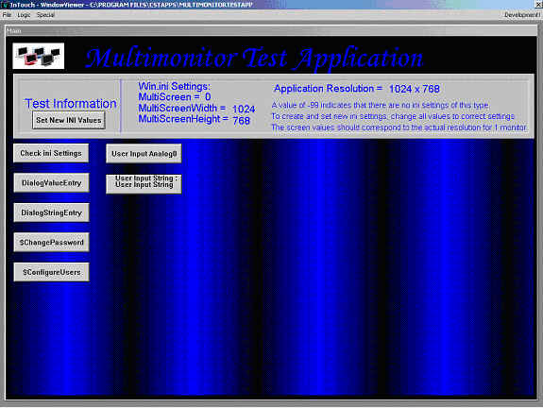
Figure 5: Multimonitor Test Application
If the application only displays on 1 monitor, this indicates that you are in MultiDeskTop Category B driver Configuration as described in this document.
If the application covers all of the monitors when started then you are in a 1 Virtual Monitor Category A driver Configuration which is ideal for InTouch.
Note You may see a message like Application requires 1024 x768, you have 4096 x 768, run WindowMaker to Convert?. Click Yes.
The application will start up normally and not convert since the ScaleForResolution setting is disabled.
The first button on the main test window will allow you to verify and change your MultiMonitor settings in InTouch.
When the button is pressed the first time you will see the present MultiMonitor Win.ini settings. If the settings show a value of -99, the ini settings do not exist. At this point you can simply enter the values for each setting from the application interface and press the Set New ini Settings button when finished.
Note The Set New ini Settings button will not appear until proper ini values have been entered.
The application must be shut down and restarted for the new ini values to take effect.
The final feature of this application is the ability to test the placement of System Dialogs and keypads on your monitors.
A few test buttons have been configured for common InTouch features that are used which require dialogs to pop up.
If the environment is set up properly for InTouch, the main test window can be manually moved from monitor to monitor and all system dialogs and keypads should show on the same monitor where the corresponding button is pushed.
For example, if the test window is dragged to monitor 2 and the $change password button is pressed, the dialog should show on Monitor 2.
This application can be easily modified by adding additional tests buttons and messages to suit your particular testing needs.
Note At the time this document was released, the functions DialogValueEntry and DialogStringEntry were not functioning properly and will display split between screens or abnormally stretched. All other buttons in the test app should display properly. These functions are presently being repaired and are listed as CRL00012497 and CRL00011721. Please feel free to contact Wonderware Technical support for additional information on repairs and when a fix will be available.
By D.Boyd and A.Rantos
Tech Notes are published occasionally by Wonderware Technical Support. Publisher: Invensys Systems, Inc., 26561 Rancho Parkway South, Lake Forest, CA 92630. There is also technical information on our software products at www.wonderware.com/support/mmi.
For technical support questions, send an e-mail to support@wonderware.com.

