Tech Note 342
Using ABCIP DAServer Version 2.0 to Access PLCs on a DH+ Network
All Tech Notes and KBCD documents and software are provided "as is" without warranty of any kind. See the Terms of Use for more information.
Topic#: 001174
Created: February, 2004

Introduction
The ABCIP DAServer (also refered to as DASABCIP) version 2.0 and higher provides access to Allen-Bradley ControlLogix, PLC5, SLC500, and MicroLogix PLC families through a standard EtherNet network interface card without requiring RSLinx software.
Acting as a communication protocol server, the ABCIP DAServer allows Windows applications, such as Wonderware's® InTouch®, to access data in PLCs connected to a Data Highway Plus network through a ControlLogix Gateway without requiring either RSLinx sofware or ControlLogix 5000 CPU in the PLC rack.
This technote explains the step-by-step procedure of how to configure and use Wonderware's ABCIP DAServer to access data in a PLC5 connected to a Data Highway Plus network.
- Before you continue, make sure you have the following:
- Install and configure the ControlLogix DH+/RIO bridge module (1756DHRIO). You will need the Rockwell Software RSLogix 5000 to configure the module.
- Connect a DH+ blue-hose cable from the ControlLogix DH+/RIO bridge module to a DH+ port on the PLC5. Make sure to assign a valid Data Highway Plus node address to the port. You will need the Rockwell Software RSLogix 5 to configure the PLC5's DH+ port.
- Install and configure the ControlLogix Ethernet or Ethernet/IP bridge module (1756-ENET or 1756-ENBT). You will need the Rockwell Software RSLogix 5000 to configure the module.
- Install and configure TCP/IP network protocol and the network interface card (NIC) so that it can communicate with the PLC via Ethernet. Make sure that you can "ping" the PLC successfully and receive valid replies from the PLC.
- Read and follow the instructions in the ABCIP DAServer's readme file and related documents for System requirements, proper installation procedures, and supported Operating systems.
- Install the latest version of the ABCIP DAServer. If a previous version was installed, be sure to uninstall it using Add/Remove program in the Control Panel.
This technote is written using for ABCIP DAServer version 2.0.0. To check the version number of the server, use Control Panel - Add/Remove Programs - select Wonderware ABCIP DAServer, then click on Support Information.
Note: Please check the ABCIP DAServer's Online Help for more information about the supported firmware and hardware.
This technote assumes the user has a basic working knowledge and understanding of Ethernet networking, Allen-Bradley software/hardware, Microsoft operating system, Wonderware FactorySuite components, WWClient, and ABCIP DAServer. If you have problem configuring the ControlLogix Ethernet or Ethernet/IP bridge module on the PLC, please contact Allen-Bradley for assistance at www.ab.com.

Configurating the ABCIP DAServer
- Start the ABCIP DAServer Manager by selecting the Programs menu from the Start button on the taskbar.
- Navigate to the Wonderware folder that contains the System Management Console, then click System Management Console.
- From the ArchestrA System Management Console (SMC), find the SIDirect DAServer in the DAServer Manager tree.
Under the local node the DAServer name is ArchestrA.DASABCIP.2 (Figure 1 below):
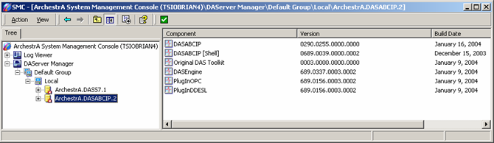
Figure 1: ArchestrA.DASABCIP.2 Server
- Expand ArchestrA.DASABCIP.2 and highlight Configuration.
The Global Parameters faceplate appears (Figure 2 below):
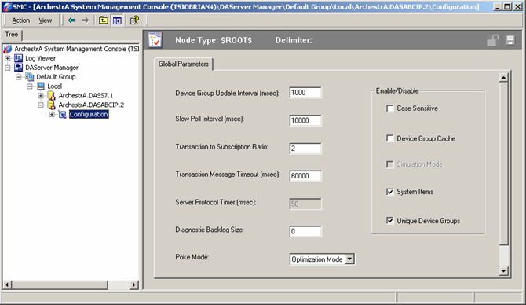
Figure 2: Global Parameters Faceplate
• Device Group Update Interval: Specifies the update interval of the default device group.
• Slow Poll Interval: Specifies the interval that the DAServer polls the field device after it goes into slow poll mode when connectivity problems occur. The DAServer will be governed by device group update intervals when the communication returns to normal.
• Transaction to Subscription Ratio: Transactions are poke/read messages from a DDE/SL/OPC client. Subscriptions are messages generated by items being on advise. Subscriptions are sent periodically at the Update Interval.Transaction to subscription ratio defines the maximum number of transactions the DAServer sends before sending one subscription. It is the ratio of transaction to subscription messages when there are several transaction messages pending. The second half of the ratio is always 1. Therefore, the default ratio 2 means 2:1 transaction to subscription messages. The ratio ensures that a certain amount of subscription activity is guaranteed even in a transaction overloaded state.
For example if the ratio is set to 2 and there are 3 transaction messages and 2 subscription messages become due at the same time, the toolkit will send out 2 transaction messages, 1 subscription message, 1 transaction message and then 1 subscription message.
• Transaction Message Timeout: Is the timeout for transactions (read/write/refresh/property) per message. This timeout prevents a client from hanging in a transaction forever if for some reason the transaction messages are never scheduled until completion. It is the maximum amount of time between message updates within a transaction. The timeout has to be set in such a way that under no circumstances data acquisition on an individual message takes longer than this timeout.
• Server Protocol Timer: This option is disabled, since the DASABCIP uses event driven protocol engine.
• Diagnostic Backlog Size: Specifies the maximum number of transactions shown in the Transactions diagnostic root.
• Poke Mode:
Control Mode preserves the poke order without folding.
Transition Mode preserves the poke order with minimum folding by keeping the first, second and last poke values of an item.
Optimization Mode does not preserve the poke order and has maximum folding by only poking the last value of an item.
• Case Sensitive: Controls how the DAServer scans item and device group names with respect to upper/lower case.
• Device Group Cache: This parameter is for future use.
• Simulation Mode: This parameter is is disabled for the SIDirect DAServer.
• System Items: This parameter controls whether the system items appear in the browse interface and if they are recognized as valid ItemIDs by the DAServer's data acquisition interfaces.
• Unique Device Groups: This parameter controls whether the device group names are checked for uniqueness across all device nodes of a DAServer.
- Right-click the Configuration icon.
- Select Add Port_CIP Object from the sub-menu.
- Right-click the New_Port_CIP_000 object, and select Add ENB_CLX Object from the sub-menu.
- Replace the default Local Host value (in the Host Name field) with an appropriate IP address for the ControlLogix Enethernet module.
The Node Type faceplate appears (Figure 3 below):
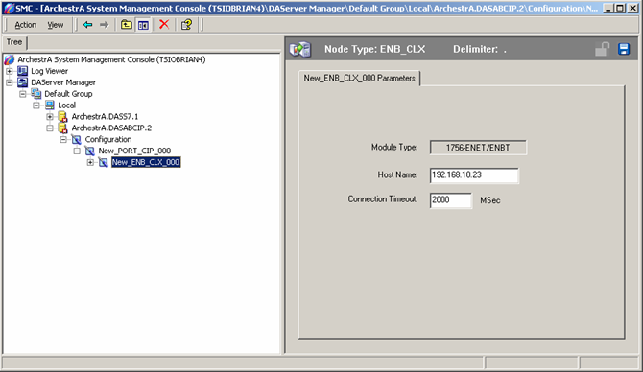
Figure 3: New_ENB_CLX_000 Parameters
• Host Name: Enter the IP address for the Ethernet module. The address used in the example of this technote has IP address of 192.168.10.23.
• Connection Timeout: Enter time in miliseconds. The connection timeout is the time the DAServer will use to estabhish a socket connection to the target PLC.
- Right click the New_ENB_CLX_000 branch, and select Add the BACKPLANE_CLX object to your ABCIP hierarchy.
The BACKPLANE_CLX is a logical representation of the backplane communications bus of the ControlLogix rack.
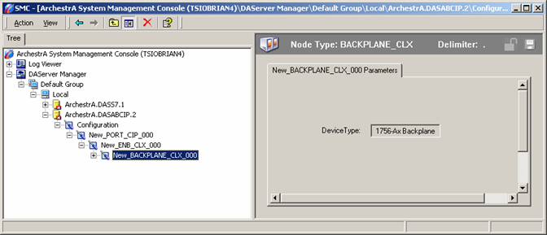
Figure 4: ControlLogix BACKPLANE_CLX
- Right click the New_BACKPLANE_CLX_000 object and select Add DHRIO_CLX Object. This adds the DHRIO_CLX object to the ABCIP hierarchy. DHRIO_CLX is a logical representation of the ControlLogix DH+/RIO bridge module.
Figure 5 (below) shows the DHRIO:
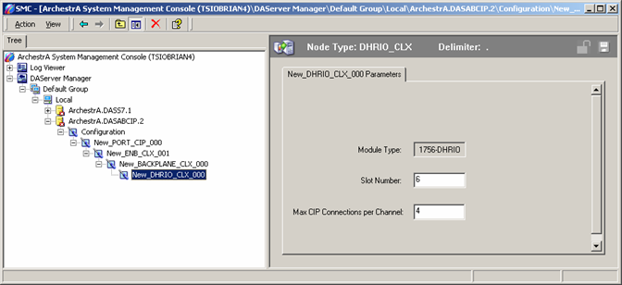
Figure 5: ControlLogix DH+/RIO Module
• Slot Number: Enter the slot number on the PLC rack where you installed the DH+/RIO module. Note that the slot number starts with zero. The DH+/RIO module in this technote is in Slot 6.
• Max CIP Connections per Channel: Enter the maximum number of CIP connections for each channel.
- Select and right click the New_DHRIO_CLX_000 object.
- Select Add Port _DHP Object.
The New_Port_DHP_000 is created as shown in Figure 6 (below).
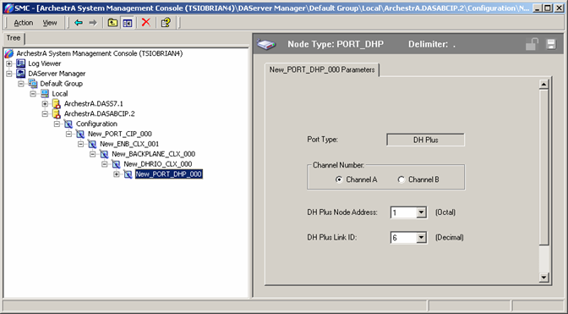
Figure 6: New_PORT_DHP_000
Where:
• Channel Number: Is the channel or Port number being used on the ControlLogix DH+/RIO module. The DH+ blue hose cable is connected to channel A to the PLC5.
• DH Plus Node Address: Enter the DH Plus node address in Octal for the DH Plus port.
• DH Plus Link ID: Enter the Link ID for the port. The link ID is defined in the DHRIO Rounting table.
- Select and right-click the New_Port_DHP_000 object.
- Select Add PLC5_DHP Object from the sub-menu.
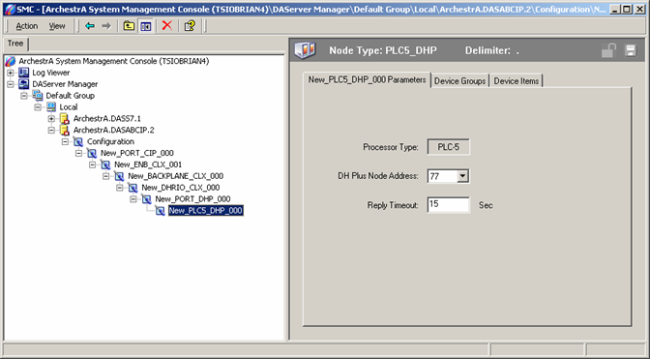
Figure 7: Configuration View for the PLC5 Data Highway Plus Object
Where:
• DH Plus Node Address: Is the Data High Way Plus node address for the channel being used in this technote.
• Reply Timeout: Enter the maximum amount of time in seconds that the DAServer will wait for a response from the PLC.
- Now, select the Device Groups tab, and right click on the white space in the Device Groups tab field to add a device group (similar to Topic Definition) in the Device Groups tab field (Figure 8 below):
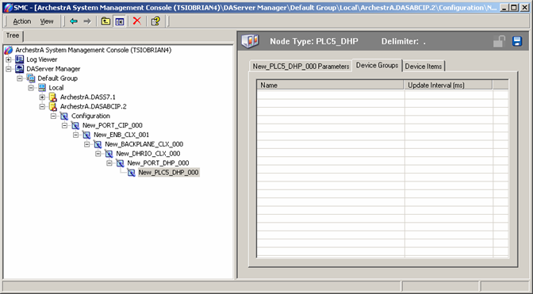
Figure 8: New Device Group
- Select and right-click the default Topic_0 name to rename it. Ensure the new name is meaningful, such as PLC520E (Figure 9 below):
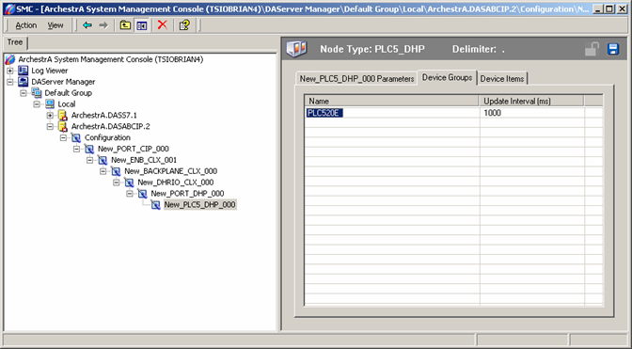
Figure 9: PLC520E Device Group
- In the hierarchy tree on the left pane, right-click ArchestrA.DASABCIP.2 and select Activate Server from the sub-menu to start the DAServer.
The Server icon next to ArchestrA.DASABCIP.2 changes from red to green (Figure 10 below):
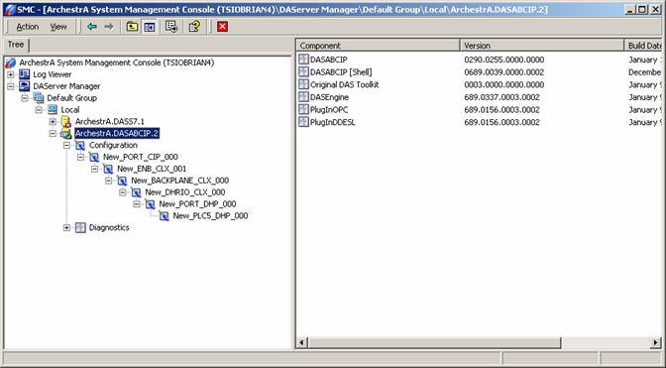
Figure 10: DASABCIP Activated

Test the DASABCIP Server
The DASABCIP is ready for use. We are now going to do a quick communications test to verify that we can establish the connection to the PLC.
- Click Start/Run from the Windows taskbar.
- Enter WWClient to start the Wonderware WWClient program.
- Select Connections/Create from the main menu bar.
The Create Connection dialog box appears.
- Enter appropriate information as shown in Figure 11 below, where:
• Node: is blank since the DASABCIP and the WWClient are on the same computer. Otherwise, enter the computer name of the machine running the DAServer.
• Application: DASABCIP, which is the application name of the ABCIP DAServer.
• Topic: PLC520E which is the exact name of the new device group we just created in the DASABCIP's device groups window.
• Connection Type: IOT - which is the SuiteLink™ protocol used for this technote.
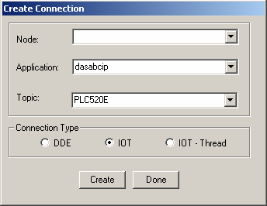
Figure 11: Create Connection
- Click Create, then Done.
The WWClient window should appear similar to Figure 12 (below):
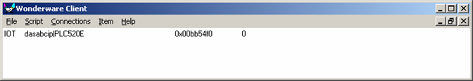
Figure 12: DASABCIP Connection
- Now, select Item on the main menu bar.
- Enter a known good PLC register address. The following figure (Figure 13 below) shows an example of WWClient successfully advising item S:23 from the PLC5.
- Click the AdviseEX button to register and advise the item. If the Ethernet connection to the PLC is good, you should see the value for the register S:23 changing:
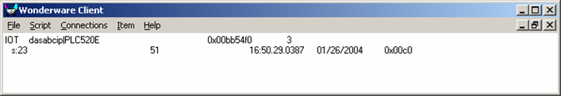
Figure 13: Successful s:23 Advise
B. Nguyen
Tech Notes are published occasionally by Wonderware Technical Support. Publisher: Invensys Systems, Inc., 26561 Rancho Parkway South, Lake Forest, CA 92630. There is also technical information on our software products at www.wonderware.com/support/mmi
For technical support questions, send an e-mail to support@wonderware.com.
back to top
©2004 Invensys Systems, Inc. All rights reserved. No part of the material protected by this copyright may be reproduced or utilized in any form or by any means, electronic or mechanical, including photocopying, recording, broadcasting, or by anyinformation storage and retrieval system, without permission in writing from Invensys Systems, Inc. Terms of Use.

