Tech Note 65
Avoiding the Password Dialog Box When Connecting to a Windows NT 4.0 Node
All Tech Notes and KBCD documents and software are provided "as is" without warranty of any kind. See the Terms of Use for more information.
Topic#: 000307
Created: May 23, 1997
When establishing a NetDDE connection to a Windows NT 4.0 node, a user must specify their user name, domain name (or workgroup), and password in the Enter Network Access Password dialog box (referred to in this Tech Note as the "password dialog box"). This is because the C2 security level of the Windows NT 4.0 operating system requires proper authentication when connecting to a Windows NT 4.0 node. This authentication is even required when connecting from one Windows NT 4.0 node to another Windows NT 4.0 node. Some users, however, prefer not to have the password dialog box appear. This Tech Note describes:
- How to keep the password dialog box from appearing more than once when connecting a Windows 95 node to a Windows NT 4.0 node
- How to keep the password dialog box from appearing at all when connecting a Windows NT 4.0 node to a Windows NT 4.0 node
Note These procedures are not related to creating and trusting DDE Shares on the server node to enable data transfer. (See Configuring DDE Shares for NetDDE in Windows NT 4.0, for more information on creating and trusting DDE Shares.)
The password dialog box is shown below:
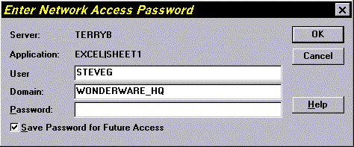

Connecting a Windows 95 Node to a Windows NT 4.0 Node
A user will always need to enter, at least once, their user name, domain name, and password in the password dialog box when attempting to connect a Windows 95 node to a Windows NT 4.0 node. This is true even if both nodes are a member of the same domain.
To keep the password dialog box from appearing more than once, create a user on the Windows NT 4.0 node in the User Manager. The user does not need to have special privileges, but it must have a real password. A blank password could create security problems. Once the user enters this user information in the password dialog box the first time, the box should not appear again unless the machine is shut down and then restarted.

Connecting a Windows NT 4.0 Node to Another Windows NT 4.0 Node
The password dialog box will not appear when a user connects a Windows NT 4.0 node to another Windows NT 4.0 node if there is a defined domain and both machines are logged onto this domain. In this case, the user must also be logged on with the priviledges that are necessary to access the server node. Otherwise, if one node is on the domain and the other node is not, then the password dialog box will appear when a connection is attempted.
To keep the password dialog box from appearing when the two nodes are on different domains, follow these steps:
- On the server node, open the User Manager, located under the Administrative Tools menu, as seen below:
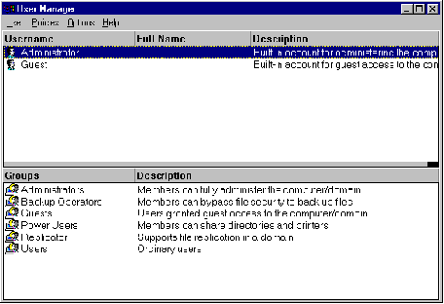
- Next, create a user and assign the user a real password, not a blank password. Click the Password Never Expires check box and then close the User Manager.
- Repeat the previous step on the client node, using the same user name and password.
- Log off of the client node and then log on again, but this time enter the user name and password that you just created. You will be able to establish a conversation to the server node without being prompted for a password, even though the two nodes are not on the same domain.
G.Olsen
The Tech Note is published occasionally by Wonderware Technical Support. Editors: Sabrina Abercromby and Kelly Hauser; Publisher: Wonderware Corporation, 100 Technology Drive, Irvine CA 92618. There is also technical information on our software products at www.wonderware.com/support/mmi, our WonderFax fax-on-demand system at (949) 450-5050, and the Comprehensive Support Knowledge Base.
For technical support questions, send an e-mail to support@wonderware.com.
back to top
© 2003 Wonderware Corporation. All rights reserved. Terms of Use.

